2-simpleapp

-I chose the java application

-I created a Dockerfile to containerize the java application

-I built the Docker image locally

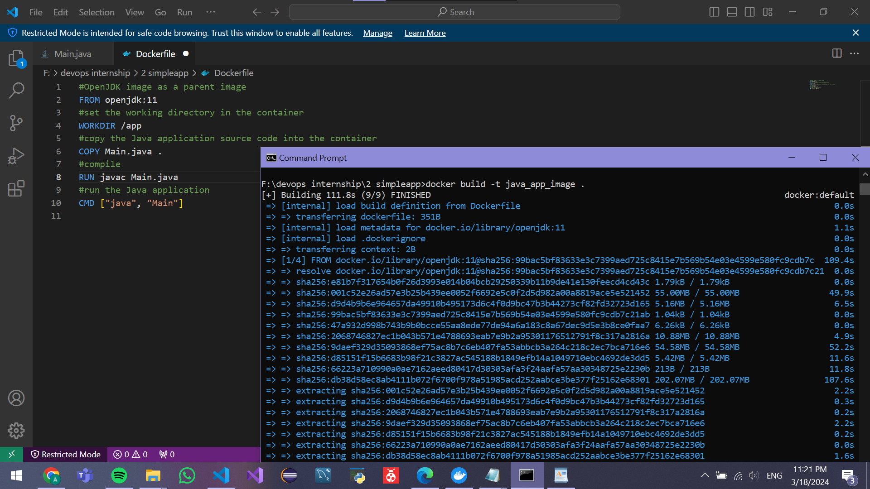

-I created a public repository

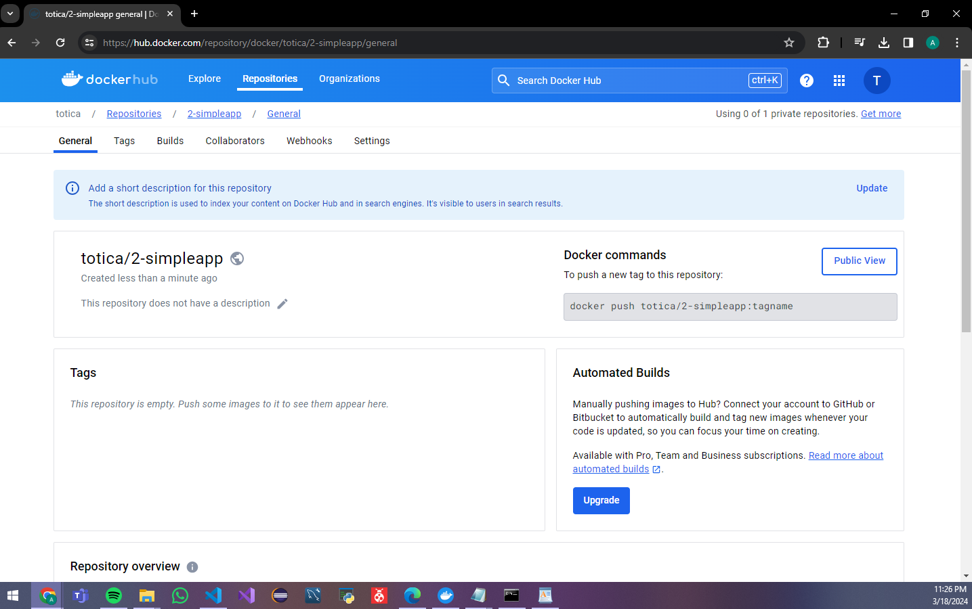

-to access the repository from github i created secret repositories with the credentials

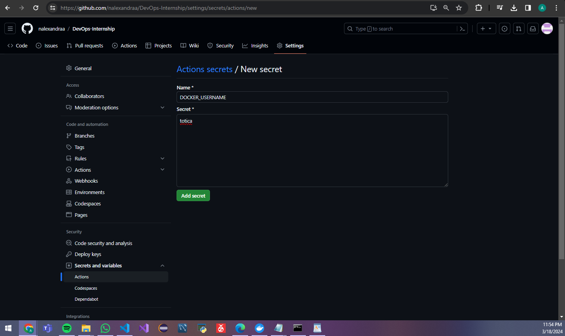

-I have defined the workflow steps to trigger the build, build the Docker image and push it to the Docker registry



